I spent way more time learning concepts and researching different ways I could go about the project, especially with how the buttons were going to work and how I could play media files on P5.js. My first idea was to make different map buttons pop out when having mouse hover over them to have more interactivity and juice for the user, but I eventually found out about radio buttons after extensive searching on StackOverflow and settled with those instead.

I never could figure out how to make the buttons lead into an Arraylist of different videos, so I ended up asking the GA. I ended up learning a lot about Arrays, and how to make a list of Arrays, and how to make different Arrays work with each other through different functions. I learned that print is pretty good in figuring out which code works and where to set up alerts to figure out where it ISN’T working.

I might take up or use coding as an accessory to future projects, but I don’t think I’ll go head-first into a career in it.

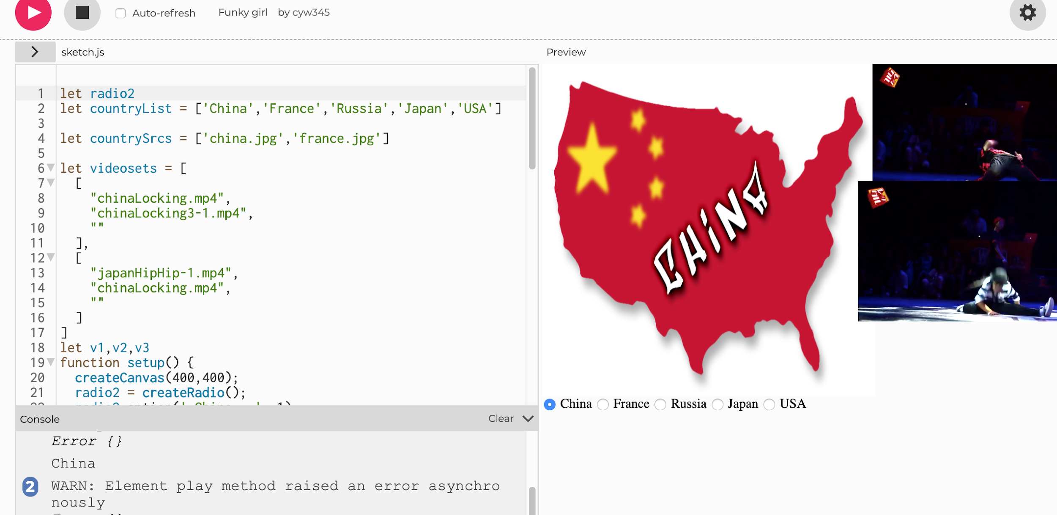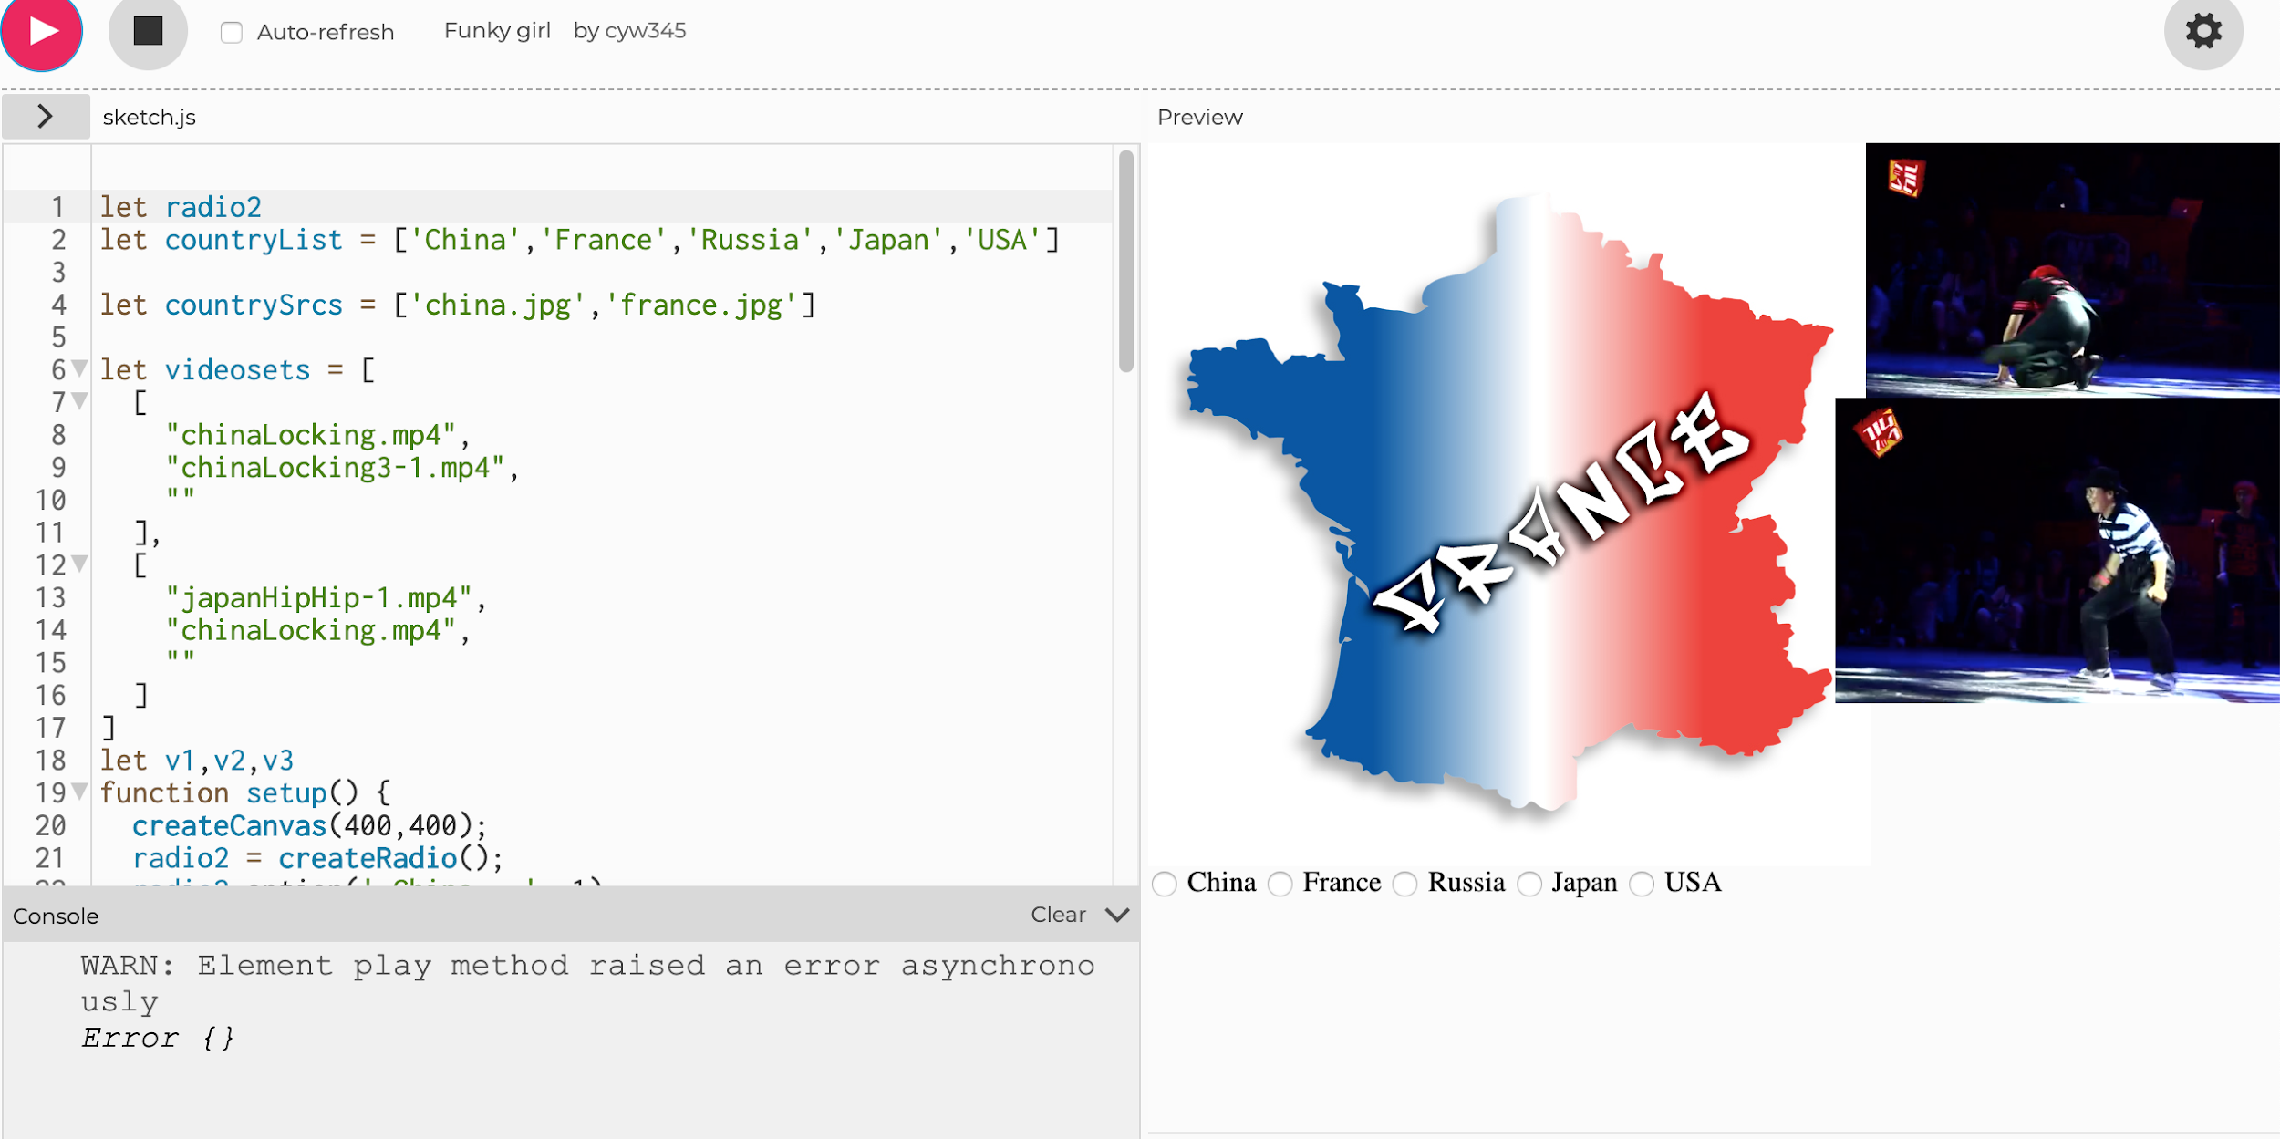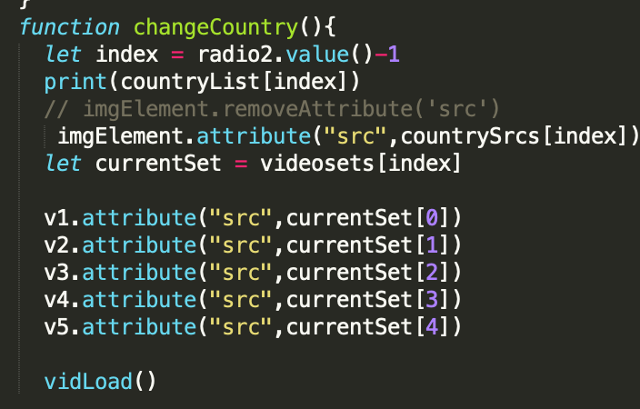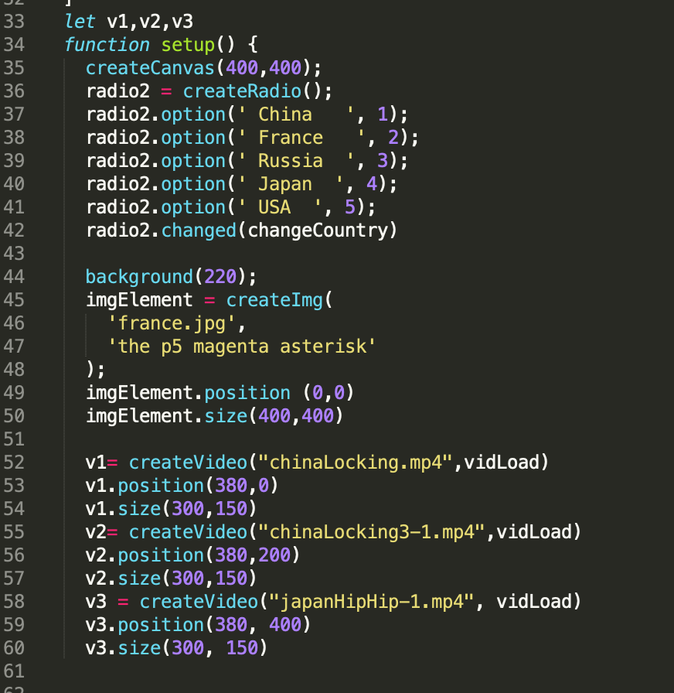

The interactive piece was about trying to teach the user what styles of urban dance have been recently popular in different countries, to get a sense of what people really like in different urban regions. The user could pick out of 5 different countries to view, each having three media clips that showcase different moves for that style of dance. The original name was supposed to be the “Urban Dance Gallery”, but got shortened to “Dance Gallery”.